Third party Capture

Independent research commissioned by the Association of British Insurers has shown that people who deal directly with the other side’s insurer receive fair compensation faster when compared with those with legal representation.

*(See http://www.abi.org.uk/Publications/ABI_Publications_Outcomes_for_legally_represented_and_ unrepresented_claimants_in_personal_injury_compensation_fc1.aspx,* ***2010****)*

For example, as much as 10% of motor premiums are spent on legal costs alone.

*(See 2007 ABI/IUA Fourth UK Bodily Injury Awards Study, pg 10,* ***2007****)*

Are there situations where it is better to have legal advice? While insurers wish to have this process open to most people, insurers will strongly recommend that independent legal advice is sought in certain situations, for example:

* If the injured person is under 18 years old.
* Where there is complexity over who was at fault for the accident.
* If you have a limited understanding of English.
* Where the injury involved requires more than one medical report or has a degree of complication, persistence or permanence.

*(<https://www.abi.org.uk/globalassets/sitecore/files/documents/publications/public/migrated/motor/third-party-assistance-claimant-guide.pdf>,* ***2010****)*

Real Time Claim Processing and Insurance Analytics. - Identifying levers to pull like; Claim Analytics involve insights of Claim Processing. Track Real-Time Claim Processing to improve customer satisfaction. Claim Scoring improves assignment and management of claims. Claim Data Processing promotes loss recovery, shortening of the claim cycle. Implementation of analytics to claim cycle yields in Return On Investment (ROI) with cost savings. Insurance Analytics Real-Time Applications

* Risk Assessment
* Automation
* Smarter Finance
* Customer- Centric
* IoT implementation
* Real-Time Trigger Based Analytics
* Hidden Revenue Opportunities

*(<https://www.xenonstack.com/use-cases/insurance-analytics-fraud-detection-ai/download/>)*

MOTOR RECOVERY

IN PRACTICE: Predictive model for recovery helps insurance carrier save $3mm.

For a global insurance carrier, Capgemini helped apply predictive analysis to help minimize the claims sent to subrogation. The claims were evaluated as follows:

1. Not all recovery claims are sent to subrogation.
2. Not all claims sent to subrogation are recovered.
3. Some claims sent to subrogation are not relevant for recovery n Actual status of referred claim may be unknown.

This may lead to less accurate models and false positives like claim appears to be subrogation but is not and false negatives like subrogation claim is not detected because this is an unknown pattern.

The Results n For automotive and workers comp, the insurance carrier can now identify and prioritize high quality recovery opportunities. The carrier achieved a 50% lift rate in quality referrals for workers comp and a 12% lift rate for automotive. Overall, the carrier projected $3mm in cost savings annually.

*(<https://www.capgemini.com/wp-content/uploads/2017/07/Claims_Analytics_for_Insurance.pdf>,* ***2017****)*

Repairer assignment

* Repair costs are rising, reflecting ever more sophisticated vehicle design and technology, which in most cases costs more to repair when damaged. Current figures show that the repair bill for insurers in the first quarter of this year was £1.2 billion, the highest quarterly figure since the ABI started collecting this data back in 2013.
* In the first three months of this year, the cost of theft payouts rose 22% to £108 million on the same period last year. The rise reflects Home Office figures recording a 50% rise in vehicle thefts over the last five years. The increase is in part being driven by keyless car crime.

*(<https://www.abi.org.uk/news/news-articles/2019/07/fall-in-the-cost-of-motor-insurance-stalls-as-the-abi-warns-of-a-bumpy-road-ahead-for-motorists/>,* ***2019****)*

Today’s figures show that:

* the average price paid for motor insurance in the third quarter of the year, at £468, fell marginally by £1 on the second quarter;
* the average premium paid fell by £3 on the same quarter last year.

*(*<https://www.abi.org.uk/news/news-articles/2019/10/competition-is-keeping-the-cost-of-motor-insurance-flatbut-for-how-much-longer/>*,* ***2019****)*

MOTOR INSURANCE

The United Kingdom (UK) motor insurance sector accounts for a considerable share of the European market. Furthermore, it also is a large part of the property and casualty insurance business in the country.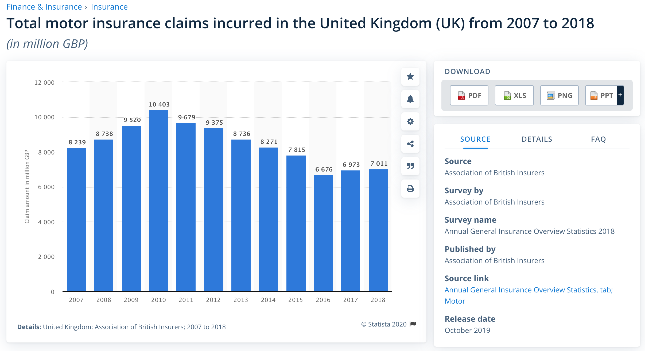

**Motor insurance claims in the UK**

In 2018, there was a total of over seven billion British pounds of motor insurance claims incurred in the UK, with the largest number of claims recorded in 2010 at more than 10.4 billion British pounds. For comparison, in 2018, insurance companies recorded over 20.7 billion euros in gross written motor insurance premiums on the domestic market.

**Fraudulent claims**

How high the pay out of a claim is depends on the severity of the damage or injury. In 2018, the average claim for bodily injury was 10.5 thousand British pounds. Not all claims are legitimate and paid out. In 2018, approximately 54 thousand claimsworth 628 million British pounds were detected as fraudulent.

(<https://www.statista.com/statistics/297435/uk-insurance-market-total-motor-insurance-claims-incurred/>*,* ***2020***)

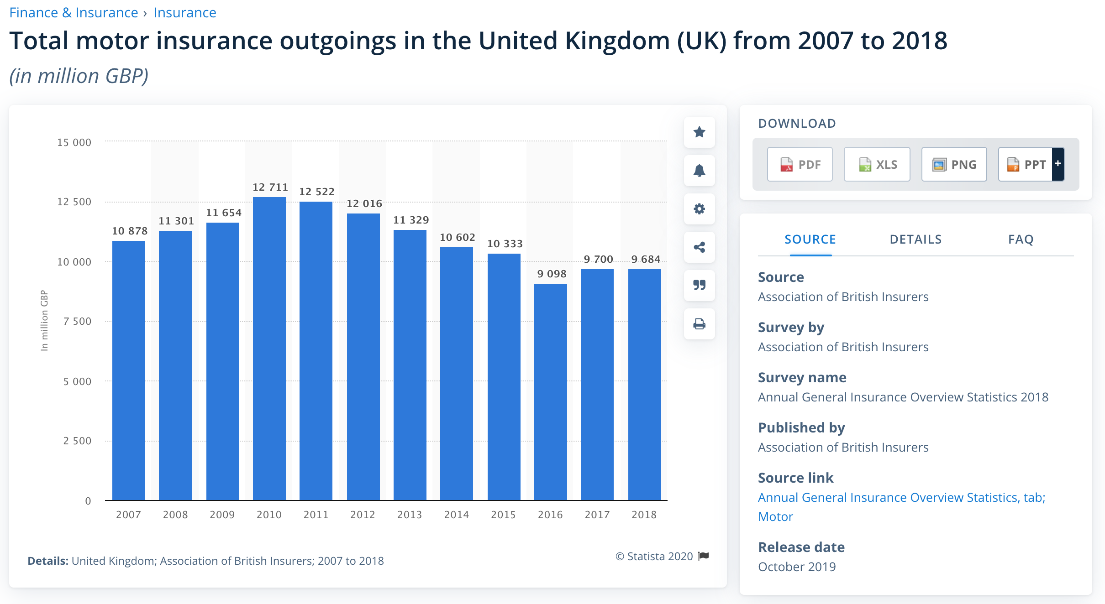

This statistic shows the total motor insurance expenses of the general business insurance market in the United Kingdom (UK) from 2007 to 2018. Between 2007 and 2018 motor insurance outgoings fluctuated. In 2018, the total motor insurance expenses amounted to nearly 9.7 billion British pounds (GBP). 2010 saw the highest value of motor insurance expenses amounting to over 12.7 billion British pounds.

(<https://www.statista.com/statistics/297429/uk-insurance-market-total-motor-insurance-expenses/>*,* ***2020***)

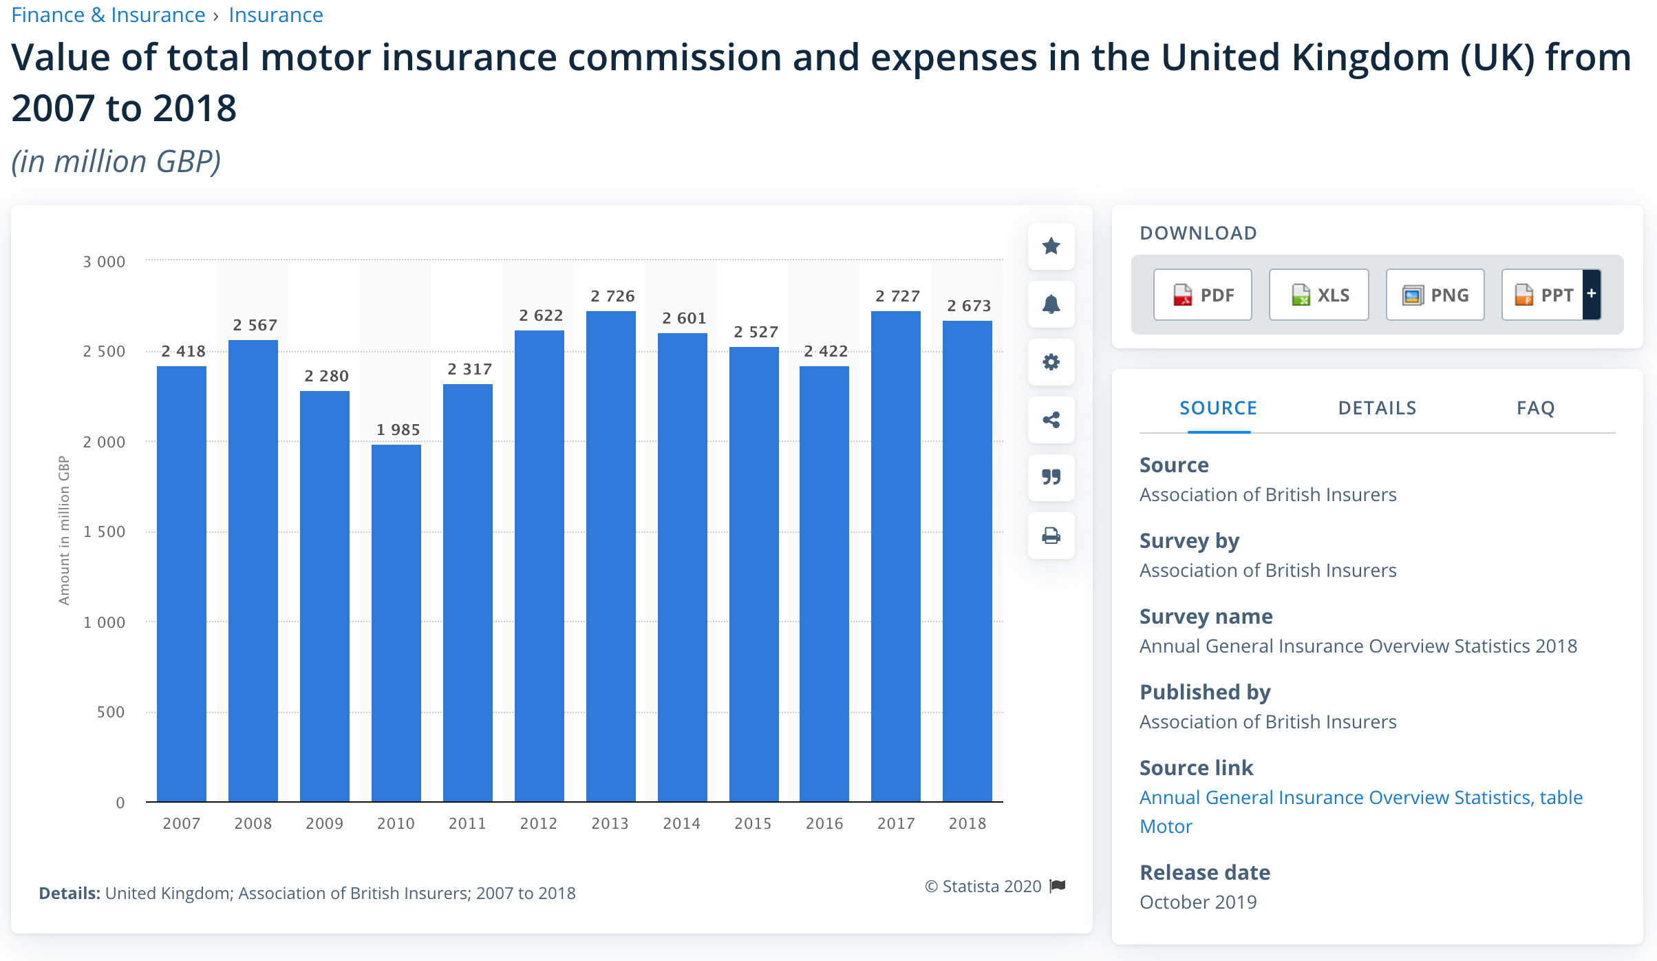

This time series shows the value of motor insurance commission and expenses of the general business insurance market in the United Kingdom (UK) from 2007 to 2018. In 2018, the value of motor insurance commission and expenses amounted to nearly 2.7 billion British pounds (GBP).

(<https://www.statista.com/statistics/297441/uk-insurance-market-total-motor-insurance-commission-and-expenses/>, ***2020***)

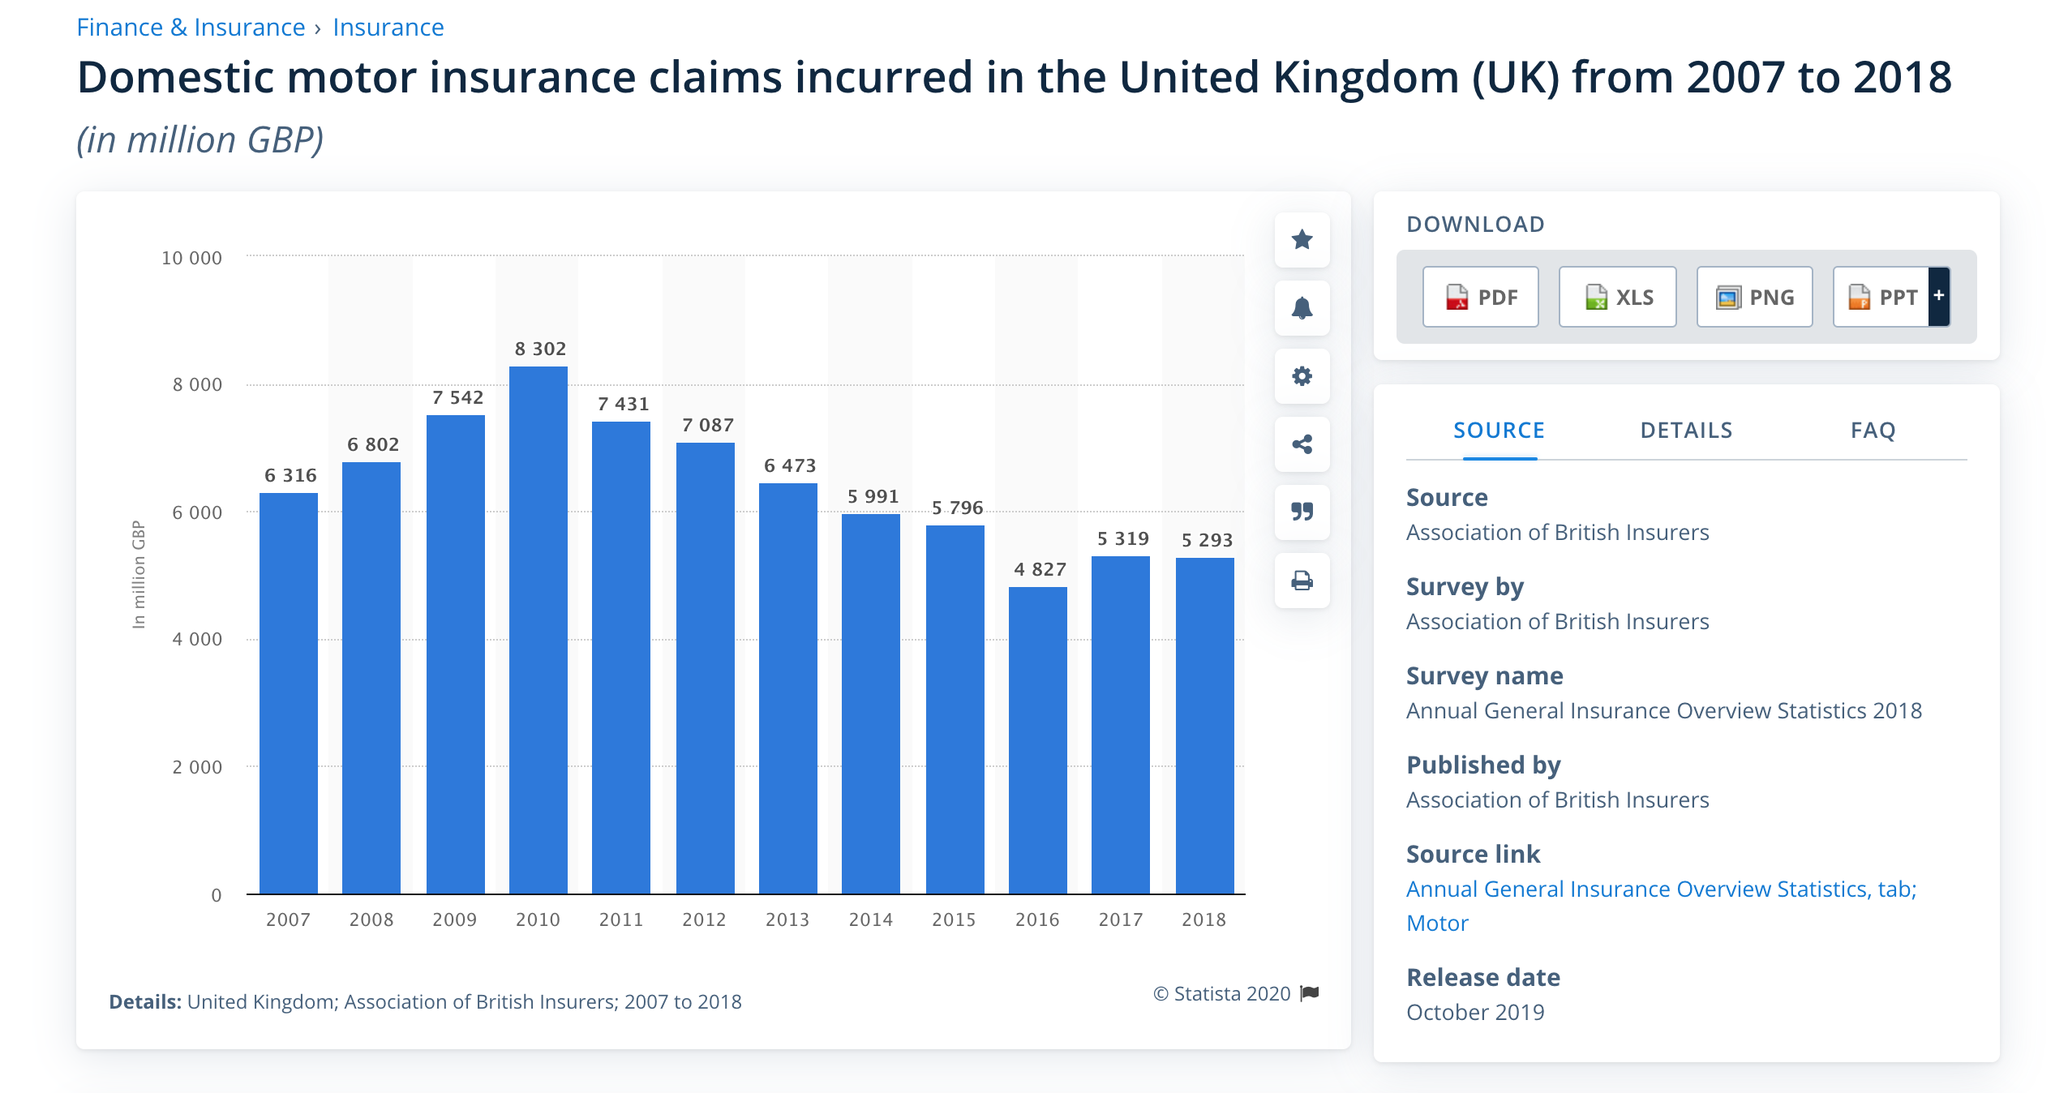

This timeline gives an overview of the domestic motor insurance claims incurred in the United Kingdom (UK) from 2007 to 2018. In 2018, the domestic motor insurance claims incurred amounted to almost 5.3 billion British pounds (GBP). Domestic claims incurred made up the majority of total claims for motor insurance in the United Kingdom.

*(*<https://www.statista.com/statistics/297436/uk-insurance-market-domestic-motor-insurance-claims-incurred/>*, ,* ***2020***)

Important key figures

MOTOR INSURANCE PREMIUMS

* Motor insurance: Gross written premiums UK 2018 - 20.72bn EUR
* Avarage motor insurance premium UK - 475 GBP
* Average weekly household expenditure on vehicle insurance UK - 11.3 GBP

MOTOR INSURANCE CLAIMS

* Total motor insurance claims 2018 - 7bn GBP  
  Total domestic motor insurance claims 2018 - 5.3bn GBP
* Personal lines motor insurance claims paid per day 2018 - 22m GBP
* Commercial motor insurance claims paid per day 2018 - 7m GBP
* Average motor insurance private car claim - 3082 GBP
* Average motor insurance bodily injury claim - 10.45k GBP

INSURTECH AND MOTOR INSURANE

* Usage based insurance (UBI) penetration in the UK - 3%
* Usage based insurance (UBI) policies growth rate UK - 32.5%
* Share of people (45-54) who bought motor insurance online UK - 61.2%

*(*<https://www.statista.com/topics/4560/car-insurance-in-the-uk/#dossierSummary__chapter3>*,* ***2020****)*

OTHER LINKS

1. *<https://www.gov.uk/cma-cases/private-motor-insurance-market-investigation#analysis>*
2. ***Important:*** *<https://assets.publishing.service.gov.uk/media/5421c2ade5274a1314000001/Final_report.pdf>,* ***2014***
3. *<https://assets.publishing.service.gov.uk/media/5329dee040f0b60a7300027b/130816_not_at_fault_survey_tables.pdf>*
4. *<https://www.sas.com/en_in/insights/articles/risk-fraud/big-data-analytics-improves-claims-processing.html>*

PERSONAL INJURY

*(<https://www.aviva.com/content/dam/aviva-corporate/documents/newsroom/pdfs/reports/aviva-UK-claims-report-2017.pdf>,* ***2017****)*

* Personal injury costs are one of the biggest costs in motor insurance, contributing 28% on average.
* Claims are rising - Latest data shows that since 2005 motor personal injury claims are around 40% higher while road accidents have fallen by nearly 35%.
* Cold calling claims cowboys are driving up costs -in the year from April 2017 there were 630 personal injury claims management companies in the UK, turning over £157 million a year. The Claims Management Regulator cancelled 45 licences and issued 252 warnings to Claims Management Companies, reflecting some of the poor practice in the sector.
* We are an international outlier when it comes to the calculation of long-term personal injury awards - At minus 0.75% we have a personal injury Discount Rate that is the lowest (and therefore the most costly) of any major economy in the world. Whiplash style claims are much more common in the UK than in other major economies.
* The average motor premium paid rose by 9% in 2017 to a record high, adding an extra £40 to the average motor insurance policy.
* Insurers have a good track record of passing on cost savings - The industry passed on savings under reforms introduced in the Legal Aid, Sentencing and Punishment of Offenders Act 2012 (LASPO), which saw premiums fall by £50 on average over the next two years.

*(<https://www.abi.org.uk/products-and-issues/topics-and-issues/personal-injury-claims/>,* ***2019****)*

Simplify the claims system so legal advice is only paid for on road traffic personal injury claims over £5,000 (rather than £1,000). - Highlights importance of predetermining claim value in PI.

*(<https://www.abi.org.uk/products-and-issues/topics-and-issues/personal-injury-claims/>,* ***2019****)*

* April 2020 reforms about to hit the sector
* The response of PI firms to the April 2020 changes
* PI claims after Brexit
* Market forecasts
* Personal injury practitioner survey

*(<https://www.businesswire.com/news/home/20191018005391/en/United-Kingdom-Personal-Injury-Market-Trends-Report-2019---ResearchAndMarkets.com>,* ***2019****)*

This statistic displays the average value of motor insurance claims - for both damage to private cars and bodily injury caused by motor accidents - in the United Kingdom (UK) from 2014 to 2018, in British pounds. In the financial year of 2017/18, the average value of bodily injury claims related to motor accidents was approximately 10.45 thousand British pounds.

*(<https://www.statista.com/statistics/829967/uk-average-payout-of-a-motor-insurance-claim/>,* ***2017/18****)*

OTHER LINKS

1. *<https://www.gov.uk/cma-cases/private-motor-insurance-market-investigation#analysis>*
2. ***Important:*** *<https://assets.publishing.service.gov.uk/media/5421c2ade5274a1314000001/Final_report.pdf>,* ***2014***
3. *<https://assets.publishing.service.gov.uk/media/5329dee040f0b60a7300027b/130816_not_at_fault_survey_tables.pdf>*
4. *<https://www.sas.com/en_in/insights/articles/risk-fraud/big-data-analytics-improves-claims-processing.html>*

CASH SETTLEMENT

**(I think we should broaden it to Repair, Replace or Cash decision making in a data driven way)**

**Recent studies show that about 60% of all buildings insurance claims are settled in cash as opposed to a managed fulfilment solution.**

Recent cases upheld by the Financial Ombudsman Service have also concluded that, when insurers have adopted cash settlement solutions, they retain certain liabilities. For example, even if the policyholder chose the repairer entirely independently, the insurer will be responsible for rectifying deficiencies in the work if the insurer or its agents have controlled the repairer, such as requiring the repairer to cut their costs or to use certain materials or parts as a result of the cash settlement.

*(*<https://www.postonline.co.uk/claims/2198274/cash-settlements-morally-wrong>*,* ***2012****)*

***Case Studies:*** *’Repair, replace or cash’ – disputes about how insurance claims are settled,*

*(*<https://www.financial-ombudsman.org.uk/files/2927/92.pdf>*, page3,* ***2011****)*

*(*<https://www.paymentshield.co.uk/Media/Default/documents/pdfs/policy-documents/Home-Insurance/RSA/Buildings_Contents_RSA-PS-019.pdf>*,* ***2019****)*

Options for settlement;

* Cash Payment: Paying cash directly to the customer gives them the option on how to control any required repairs and how quickly they might wish to get the work arranged but may need the approval of the lender if the property is mortgaged.
* Repair: Many customers may prefer the option of the insurers appointing their own preferred contractors. This can often take away the stress and worry of arranging builders and trying to ensure that they turn up on time, do a good job and that they are being charged a fair price.
* Reinstatement: Reinstatement is a more onerous form of indemnity (for the insurer), who takes possession and assumes full responsibility for the repair, irresp

*(<https://www.cila.co.uk/cila/download-link/sig-downloads/claims-management/132-desktop-handling-options-for-settlement/file>)*

Key claims figures, Aviva UK claims report July 2018;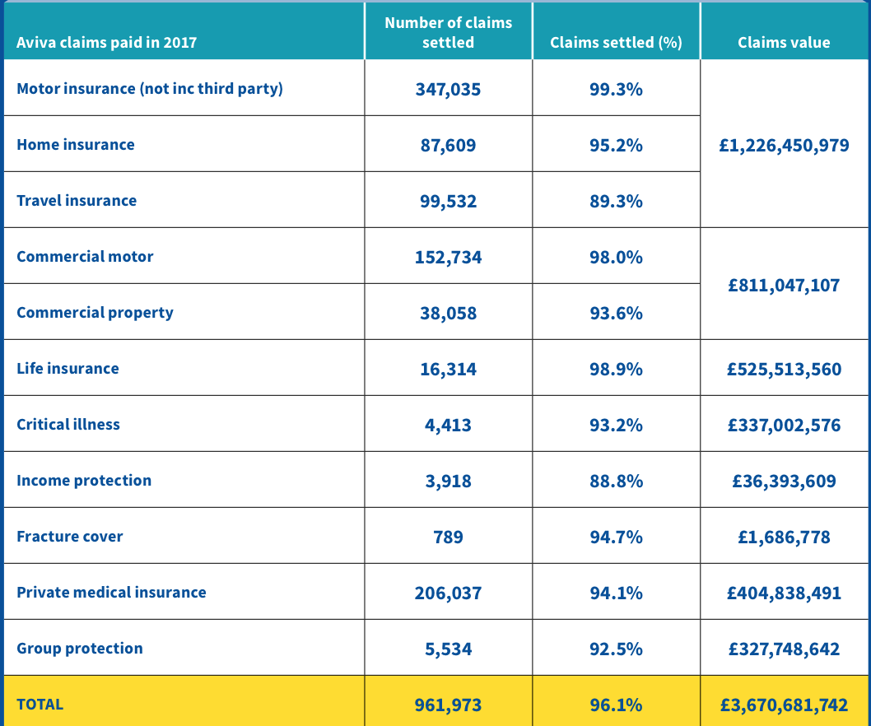

*(<https://www.aviva.com/content/dam/aviva-corporate/documents/newsroom/pdfs/reports/aviva-UK-claims-report-2017.pdf>,* ***2018****)*

Most insurance policies allow the insurer to settle a claim by repairing, replacing or paying for the items that are loss or damaged. Most insurers will choose to repair or replace items using their own network of suppliers. This helps to keep their costs down and means lower premiums for customers. However, if you don’t want your insurer to replace an item, for example because it had a sentimental value that can never be replaced, the insurer will normally agree to make a cash payment. However, this payment will be limited to the amount it would cost the insurer to replace the item. Some insurers will settle a claim by giving you vouchers rather than cash so that you can replace the item with one of your own choice.

*(<https://www.abi.org.uk/globalassets/sitecore/files/documents/publications/public/migrated/home/common-questions-about-home-insurance.pdf>,* ***2012****)*

Insurers will not give you the cost of VAT on the repairs, so there is an instant 20% reduction in the value of a cash settlement. The insurance company will also only give the equivalent cash value to the cost that they would have paid for the rebuild to be carried out by one of the builders on their panel. Builders often offer insurers preferential rates, as in return they may receive additional future work through them. They will be working to rates that the vast majority of homeowners would not be able to negotiate with a building company.

*(*<https://www.morganclark.co.uk/about-us/blog/cash-settlement-insurance-claims-explained/>*,* ***2018****)*

Subsidence and other types of ground movement;Some ways to put ground movement claim complaints right include:

* finding a fair cash outcome
* underpinning and other repairs
* making an effective and lasting repair
* when to repair and when to replace?
* finding a good match
* stabilising the building
* superstructure repairs

*(*<https://www.financial-ombudsman.org.uk/businesses/complaints-deal/insurance/home-buildings-insurance/subsidence-types-ground-movement>*,* ***2020***)

Helping to find a fair cash settlement following water damage; When Simon made a claim for water damage, his insurer asked him to get some quotes for the repairs. But inconsistency between quotes led Simon to getting in touch with us.

(<https://www.financial-ombudsman.org.uk/decisions-case-studies/case-studies/helping-find-fair-cash-settlement-following-water-damage>)

Problems in cash settlement evaluation;

* A cash settlement may be less than you expect.
* A cash settlement may turn out to be less than the amount the insurer would have paid its preferred builders.
* The insurer may pay for you to live in temporary accommodation.
* The home may not be insurable until it is repaired.
* Insurer would be responsible for arranging the repairs to your property.
* Insurer might be responsible for repairing property damage discovered later.
* Insurer must make that they are getting a good deal from your builders.

*(*<https://www.canstar.com.au/home-insurance/home-insurance-cash-settlement/>*,* ***2018****)*

SuPPLIER ASSIGNMENT

**(I think we should broaden it to generic assignments like loss adjuster, supplier and then talk about specifically supplier as an intervention to drive dependencies from)**

Aspects of the invention are directed to methods and systems for efficiently communicating data between an insurer and a non-referral repair shop, e.g., vehicle repair shops that are normally not preapproved by the insurer to perform the estimating and repair work. The methods and systems described herein are particularly useful for insurers utilizing non-referral repair shops for servicing vehicles involved in insurance claims. According to aspects of this invention, the insured may be able to select a non-referral repair shop, not delegated or preapproved by the insurer, thereby generally allowing the insured to select any available vehicle repair shop.

*(*<https://patents.google.com/patent/US8265963B1/en>*,* ***2012****)*

It is generally estimated within the industry that 60% to 70% of claims can be handled in a fully automated fashion and that this approach significantly increases the Net Promoter Score and customer satisfaction scores.

Reduced costs of administering claims can result in a four percent operational cost advantage (McKinsey); controlling spend via an approved supplier network can achieve a 33% lower cost of claims procurement (SAP benchmark) and a 70% reduction in Maverick spend. Other areas of claims leakage, such as uncollected excess payments, can be eliminated, given a robust and controlled end-to-end environment.

Given the hypothesis that 60%-70% of claims are straightforward and can be settled immediately, far fewer claims handlers and contact center operators will be required, leading to employment cost savings. There will also be lower back-office admin costs, a place where traditional claims processing and status updates can languish for long periods of time.

In fact, one UK home insurance provider found that 70% of claims registered led to service inquiries, and the average time to complete a claim was 46 days. This is driving the company to implement a robust digital claims capability.

*(<https://www.digitalistmag.com/customer-experience/2019/04/10/digitally-fully-automated-claims-is-not-2030-dream-its-possible-today-06197774/>,* ***2019****)*

Claimatic is the insurance industry's first solution dedicated to automating claim routing and assignment. By allowing your operations team to incorporate an unlimited array of decision criteria, the most ideal resources are assigned to each claim compared to the simple round robin approach used by most leading platforms.

As claimed by claimatic, following are the estimated imporvements;

* 22% Reduced Assignment Cost
* 64% Reduced Daily Drive time
* 14% Reduced Policy Churn
* 15% Increased NPS

The above are strictly claimed by provider.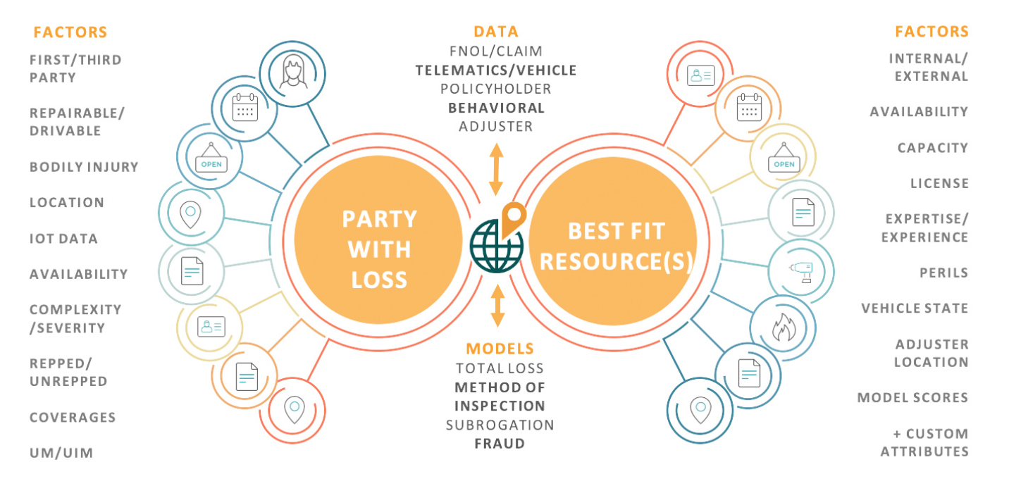

*(<https://www.claimatic.com/product/>)*

Process Management - Dynamic business process management based on defined characteristics and process exceptions.

* Business Rules Management Engine - Dynamic rules facilitate straight-through checking of various policy breach conditions; hence, helping the claims officer's decision to approve/reject the claim.
* Flexibility and Management of Workflow - Workflow flexibility ensures that a carrier can perform to its promised levels of customer responsiveness at all times. Further, it enables carriers to control overhead, labor and data storage costs, while bridging costly gaps between business processes.
* Efficient Data Capture - Configurable user interface to define data elements as per specific requirements.
* Increased Collaboration - A secure shared workspace on the corporate intranet or an external web site facilitates cooperation among all parties to a claim and shortens the time it takes to settle the claim.
* Standard Integration Architecture - Seamless integration with third party and legacy applications such as Core Policy System etc.
* Communication Platform - System based triggering of text and mails to customers as well as internal employees at relevant business stages.
* Dashboards - Sophisticated data analysis that goes far beyond canned standard reports

(<https://landing.newgensoft.com/hubfs/_2020%20Website%20files/Brochures/Brochure_%20Claims%20Automation%20Solution.pdf>, **2020**)

Even in the most modern integrated claims management systems, assigning claims to adjusters and other resources is an intensely manual and inconsistent process resulting in deployments made without consideration of an adjuster’s skills, licenses, proximity, capacity or availability. As a result, long delays between FNOL (first notice of loss), claims assignment and ultimate resolution can occur, especially during catastrophic events, causing dissatisfied customers and a high policy-turnover rate. Part of the problem is due to lack of locational awareness or intelligent placement of resources with electronic geo-fenced territories that can drastically reduce windshield time, increasing productivity while reducing costs.

*(*<https://www.businesswire.com/news/home/20180521005211/en/Claimatic-Utilizes-Real-Time-Dynamic-Data-to-Assign-Insurance-Claims-Automatically-and-Intelligently>*,* ***2018****)*

Factors to consider in supplier assignment;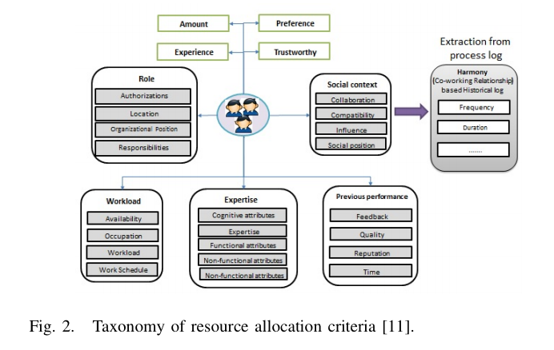

*(<https://thesai.org/Downloads/Volume9No7/Paper_34-A_Resource_Recommendation_Approach.pdf>,* ***2018)***

**Important;** Communication of insurance claim data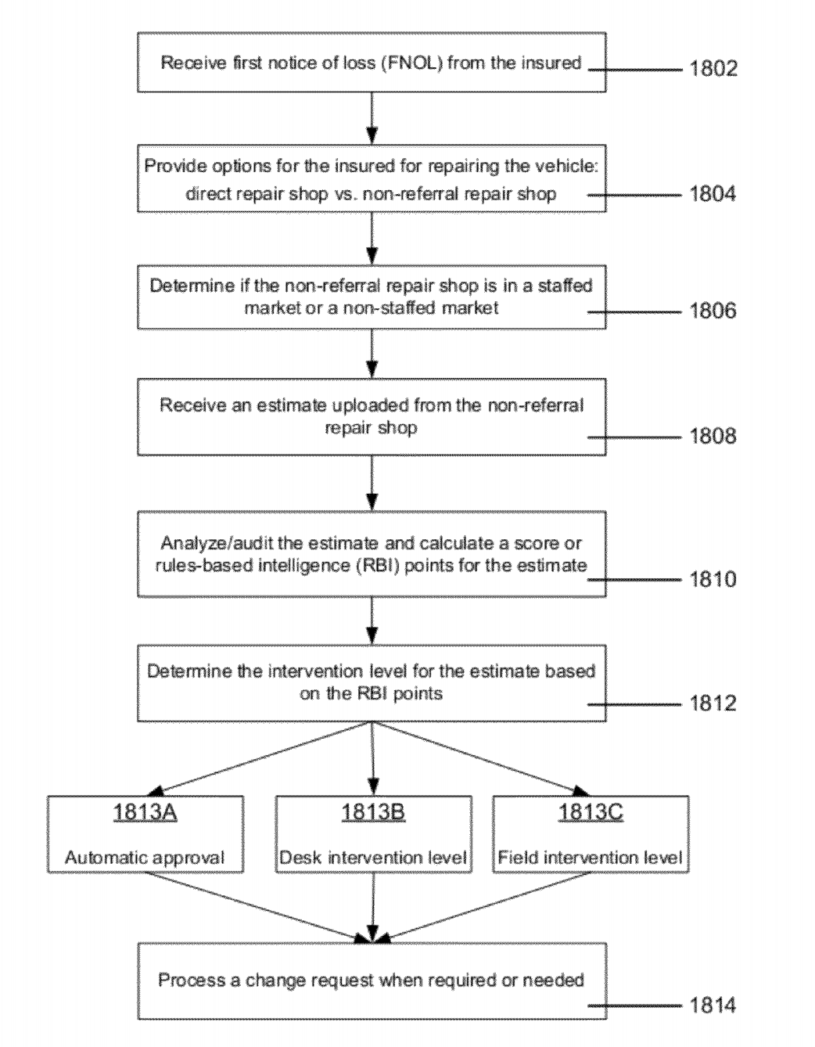

*(*<https://patentimages.storage.googleapis.com/ec/4b/e5/b620c41254c92d/US8265963.pdf>*,* ***2012***

Below is for vehicle claims but applicable to home claims with applicable modifications.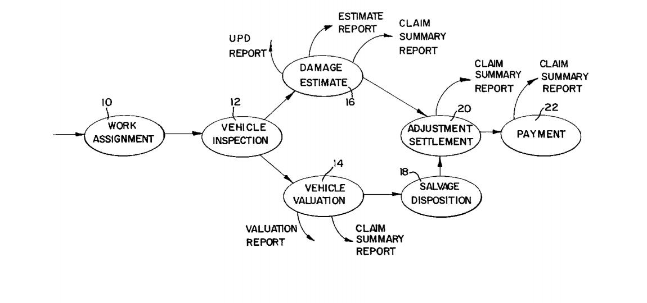

*(*<https://patentimages.storage.googleapis.com/c0/f5/c6/ac79de269b246c/US5950169.pdf>*,* ***1999****)*

COMMERCIAL INSURANCE

**[WHITE PAPER]** Deloitte: Commercial Claims - A customer focussed journey.

*(<https://www2.deloitte.com/content/dam/Deloitte/uk/Documents/financial-services/deloitte-uk-fs-commercial-claims.pdf>)*

**[ARTICLE]** Common Problems Commercial Property Owners Encounter When Submitting Damage Claims.

* Your claim is delayed.
* Your claim is denied.
* The offer from the insurance company doesn’t cover the full extent of damages to your commercial property.

(<https://www.vosslawfirm.com/library/common-struggles-in-commercial-insurance-claims.cfm>)

**[BLOG]** Delivering complaints excellence in the insurance sector.

We have calculated that firms could increase their long-term customer retention rates from a little under 50% to as much as 75% by delivering a speedier, more effective complaints experience.

(<https://www.abi.org.uk/news/blog-articles/2019/09/delivering-complaints-excellence-in-the-insurance-sector/>)

**[RESTRICTED PAPER]** United Kingdom Commercial Property Insurance Market Report, 2004-2024 Analysis & Forecast - ResearchAndMarkets.com

Key Highlights

* In 2018 the commercial property market grew by 4.1% to 5.6bn in GWP, with a five-year compound annual growth rate of 3.2%.
* Underwriting profitability fell to a 10-year low in 2018 as insurers recorded a loss of 317m.
* All new construction work saw a slight rise in 2018, although growth slowed significantly from 2017. In addition, new orders declined for the second year running due to Brexit uncertainty.
* Aviva continues to lead the market, after growing its market share in 2019 to 16.9%. AXA overtook Zurich to capture second place, with Allianz and RSA making up the rest of the top five.

Reasons to Consider

* Benchmark yourself against the rest of the market.
* Ensure you remain competitive as new innovations and significant market developments occur.
* Be prepared for how the commercial property sector could be affected following the UK's decision to leave the EU.

This statistic shows the total commercial property insurance expenses of the general business insurance market in the United Kingdom (UK) from 2007 to 2018. In 2018, the total commercial property insurance outgoings amounted to over three billion British pounds (GBP).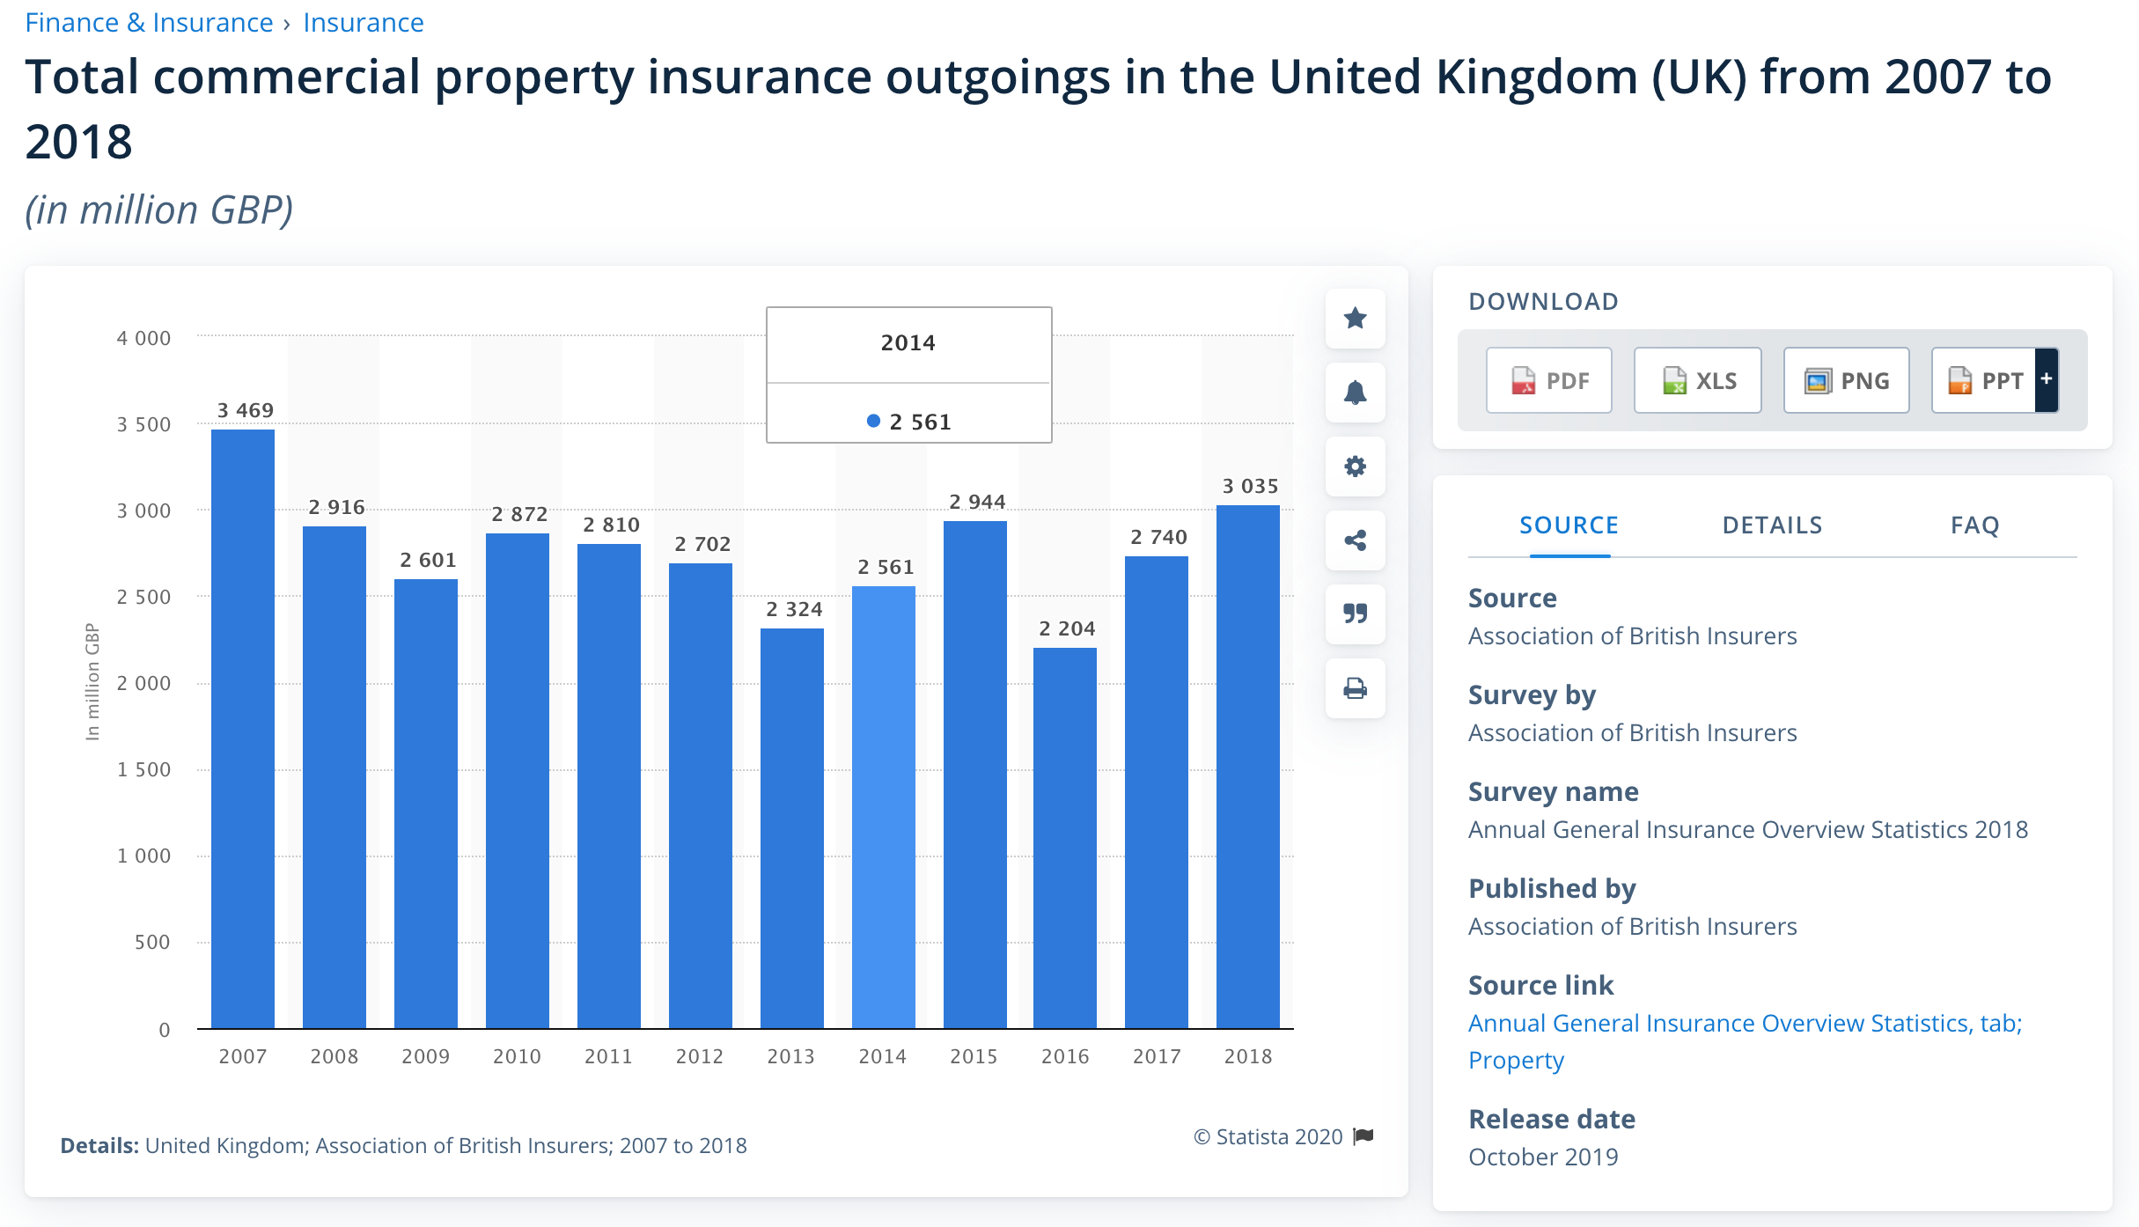

*(<https://www.statista.com/statistics/297426/uk-insurance-market-total-commercial-property-insurance-damage-expenses/>,* ***2018****)*

**[ARTICLE]** UK Commercial Property Insurance: Key Trends, Challenges and Priorities Infographic.

Managing profitability and intense price competition are the biggest challenges in the commercial property insurance market today.  While smart building technology along with automation and digitisation were named by commercial property insurers as key trends, the top ranking priority for commercial property insurers is investment in data, analytics and technology.

*(<https://blogs.lexisnexis.com/insurance-insights/2017/07/uk-commercial-property-insurance-key-trends-challenges-and-priorities-infographic/>,* ***2017****)*

RANDOM

Between 2018 and 2024, Statista estimates that the value of business-to-customer (B2C) insurance premiums written for property insurance online will overtake traditional methods. Combined, B2C premiums written for property insurance in the United Kingdom is forecast to reach a total value of over 12.1 billion British pounds by 2024, with online premiums amounting to over 52 percent of all premiums written.

*(https://www.statista.com/statistics/1060713/share-of-online-and-offline-property-insurance-premiums-written-united-kingdom/)*

Between 2018 and 2024, Statista estimates that the value of business-to-consumer (B2C) insurance premiums written for property insurance online will overtake traditional methods. Combined, B2C premiums written for property insurance in the United Kingdom is forecast to reach a total value of over 12.1 billion British pounds by 2024, a decrease of over 300 million GBP from 2018.

*(https://www.statista.com/statistics/1060700/total-value-of-online-and-offline-property-insurance-premiums-written-united-kingdom/)*

***[ARTICLE]***What’s happening in the market and what will impact your premiums in the coming years.

*(<https://www.alan-thomas.co.uk/news/property-insurance-update-september-2020/>,* ***2020****)*

LIMITATIONS OF DATA AND RESOLVING THEM

Firms will use these data to help assess the value of their insurance products, compare to peers and where appropriate make improvements. We do not expect the data to inform customers’ purchasing decisions. Consumers buying insurance may use the value measures data, but they should also consider factors like prices, product benefits, breadth of cover, excess levels, complaints volumes, average claims settlement periods and product assessment websites.

When using these value measures data, you should also be aware of the following data limitations:

* The data are aggregated
  + The value measures data reflect the aggregated data for individual firms and products. The data will reflect the mix of business undertaken by that firm and may not reflect individual distributor or brand arrangements. It may also not represent individual insurance products purchased by different consumers from the same insurer.
  + **Solution;** Collection of representative data.
* The data reflect past performance
  + The published data relate to the year ending 31 August 2018. The data may vary in subsequent years. This variation may be caused by a variety of factors.  For instance, poor weather conditions such as floods or storms can increase both the frequency of claims and claim pay-outs.
  + **Solution;** Optimising generalisation and complexity of analysis
* Actual claim pay-outs can vary significantly from the average.
  + The average claim pay-outs include payments to policy beneficiaries and other relevant costs incurred by insurers to resolve claims. For example, services provided when dealing with home emergency. These costs will typically be lower than those of an independent tradesperson appointed by a customer in an emergency situation.
  + **Solution;** Segmented analysis and implementation.
* Average claims pay-out and claims frequency will be influenced by a variety of factors such as the level and type of cover
  + Some insurers may predominately sell specialist or high-end products. In this case the sum insured may be considerably higher, resulting in higher claims costs.
  + **Solution;** Varied analysis and model customisations reflecting both tactical recommenders systems and strategic business rules.

|  |  |  |  |
| --- | --- | --- | --- |
| **Firm** | **Claims frequency** | **Claims acceptance rate** | **Average claim pay-out** |
| Admiral Insurance (Gibraltar) Limited | 2.5% to 4.9% | 90% to 92.4% | £2,500 to £2,999 |
| Ageas Insurance Limited | 2.5% to 4.9% | 82.5% to 84.9% | £3,500 to £3,999 |
| Allianz Insurance plc | 5% to 7.4% | 92.5% to 94.9% | £3,500 to £3,999 |
| Amtrust Europe Limited | 5% to 7.4% | 92.5% to 94.9% | £3,000 to £3,499 |
| Aviva Insurance Limited | 2.5% to 4.9% | 95% to 97.4% | £3,500 to £3,999 |
| AXA Insurance Uk Plc | 2.5% to 4.9% | 90% to 92.4% | £3,500 to £3,999 |
| Axis Capital/ Novae Syndicates Limited | 2.5% to 4.9% | 90% to 92.4% | £3,500 to £3,999 |
| Brit Syndicates Limited | 7.5% to 9.9% | 80% to 82.4% | £1,500 to £1,999 |
| Canopius Managing Agents Limited | 2.5% to 4.9% | 90% to 92.4% | £5,500 to £5,999 |
| CIS General Insurance Limited | 5% to 7.4% | 87.5% to 89.9% | £3,000 to £3,499 |
| Cornish Mutual Assurance Company Limited | 12.5% to 14.9% | 95% to 97.4% | £2,000 to £2,499 |
| Covea Insurance plc | 2.5% to 4.9% | 90% to 92.4% | £3,500 to £3,999 |
| Ecclesiastical Insurance Office Plc | 10% to 12.4% | 92.5% to 94.9% | £7,500 to £7,999 |
| esure Insurance Limited | 2.5% to 4.9% | 92.5% to 94.9% | £3,500 to £3,999 |
| Great Lakes Insurance SE | 2.5% to 4.9% | 85% to 87.4% | £3,000 to £3,499 |
| Gresham Insurance Company Limited | 5% to 7.4% | 95% to 97.4% | £3,500 to £3,999 |
| Hiscox Insurance Company Limited * | 5% to 7.4% | 95% to 97.4% | £8,000 to £8,499 |
| Legal and General Insurance Limited | 2.5% to 4.9% | 90% to 92.4% | £2,000 to £2,499 |
| Liberty Insurance Limited | 5% to 7.4% | 97.5% to 100% | £4,000 to £4,499 |
| Liverpool Victoria Insurance Company Limited | 2.5% to 4.9% | 92.5% to 94.9% | £4,000 to £4,499 |
| Lloyds Bank General Insurance Limited | 5% to 7.4% | 87.5% to 89.9% | £3,500 to £3,999 |
| Royal & Sun Alliance Insurance Plc | 5% to 7.4% | 97.5% to 100% | £3,000 to £3,499 |
| St Andrew's Insurance Plc | 2.5% to 4.9% | 85% to 87.4% | £6,500 to £6,999 |
| Tesco Underwriting Limited | 2.5% to 4.9% | 87.5% to 89.9% | £1,500 to £1,999 |
| The National Farmers' Union Mutual Insurance Society Limited | 7.5% to 9.9% | 97.5% to 100% | £6,500 to £6,999 |
| The Salvation Army General Insurance Corporation Ltd | 2.5% to 4.9% | 95% to 97.4% | £4,000 to £4,499 |
| UK Insurance Ltd | 5% to 7.4% | 92.5% to 94.9% | £2,500 to £2,999 |
| Zenith Insurance Plc | 5% to 7.4% | 87.5% to 89.9% | £3,500 to £3,999 |
| Zurich Insurance PLC | 5% to 7.4% | 97.5% to 100% | £4,000 to £4,499 |

*(<https://www.fca.org.uk/data/general-insurance-value-measures-data-year-ending-31-august-2018>,* ***2018****)*